**Day-2 (01/12/2022)**

**B.Koushik(221910307015)**

**1. Create a Biodata, and display your details.**

**i) Create a User.js file in src**

**ii) Copy the contents from the App.js into User.js. Make the changes in code (Rename App as User in User.js) and add the biodata**

**iii) Import the User.js in Index.js**

**iv) Now run the code using “npm start” in cmd**

**User.js**

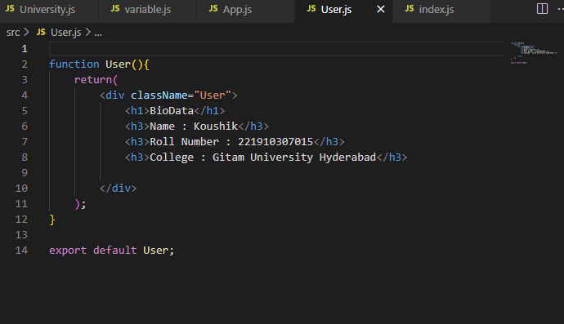

**App.js**

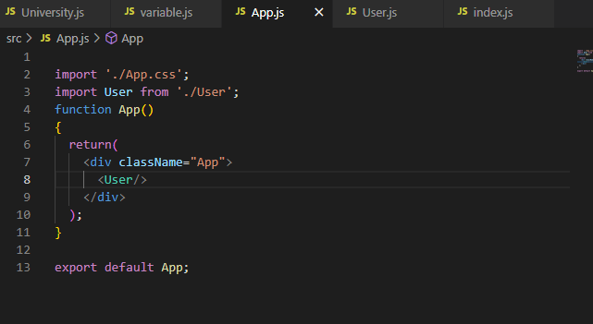

**Index.js**

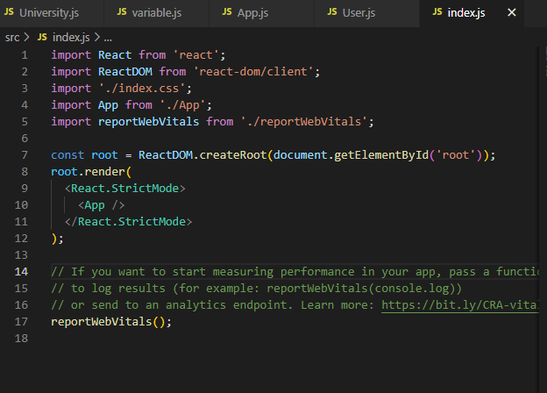

**Output :**

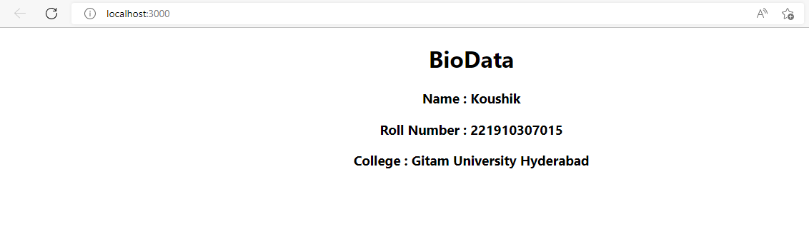

**2. Create a file called “Gitam.js” in that file write the sentence “GITAM UNIVERSITY is located in Hyderabad - 221910307015”. Execute the Gitam.js by importing the file into Index.js file.**

**Gitam .js**

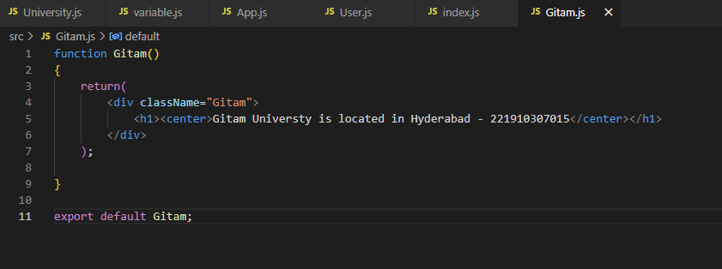

**Index.js**

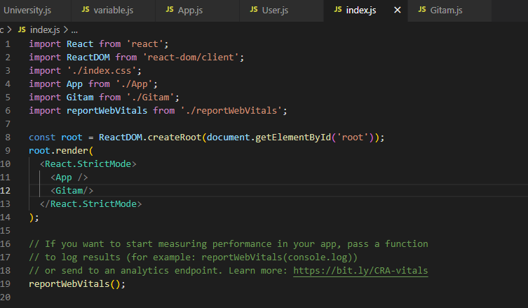

**Output :**

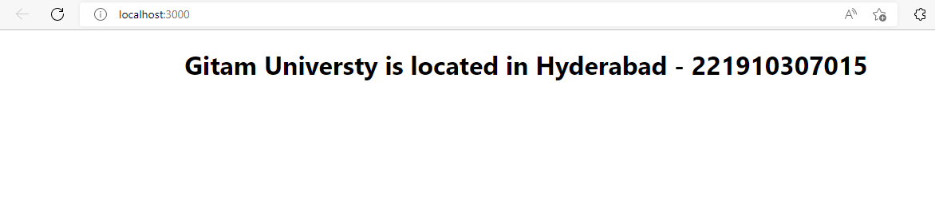

**3. Print the sentence “GITAM University is located in Hyderabad-221910307015” three times**

**(Here call the Gitam Function 3 times to get the expected output).**

**Index.js**

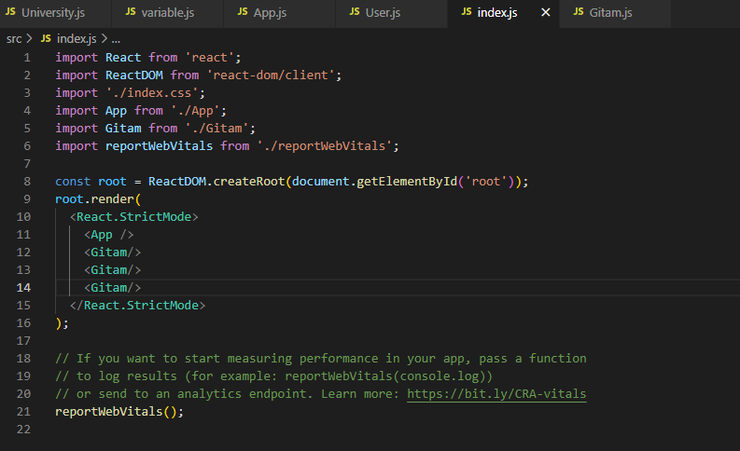

**Output :**

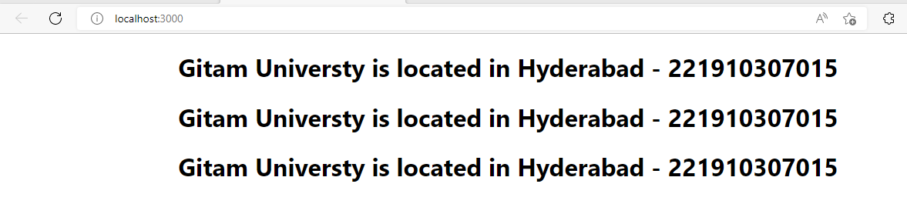

**4. Create a new module (Module1.js) and import it into Gitam.js, then import Gitam.js into App.js then import App.js into Index.js.**

**Module1.js is used to print name and roll number**

**Module1.js**

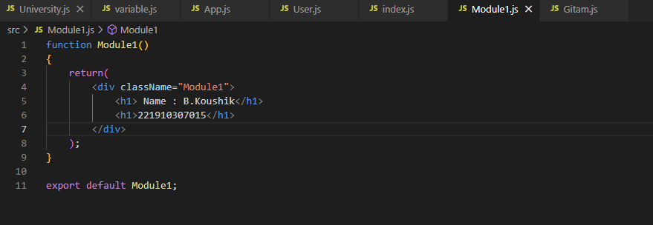

**Gitam.js**

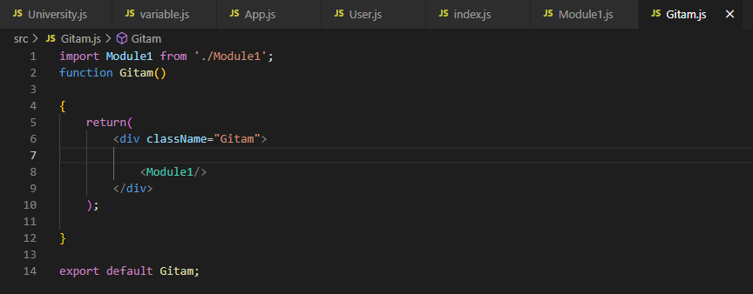

**App.js**

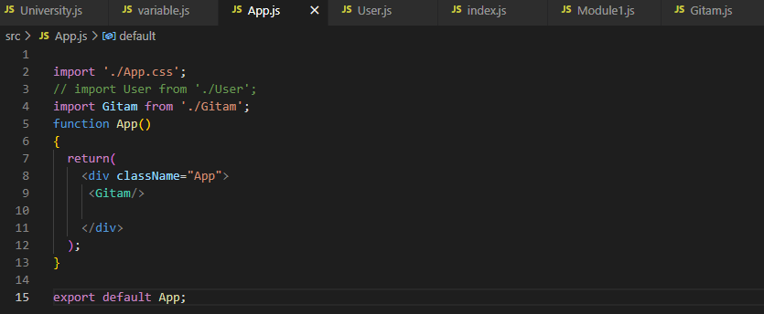

**Index.js**

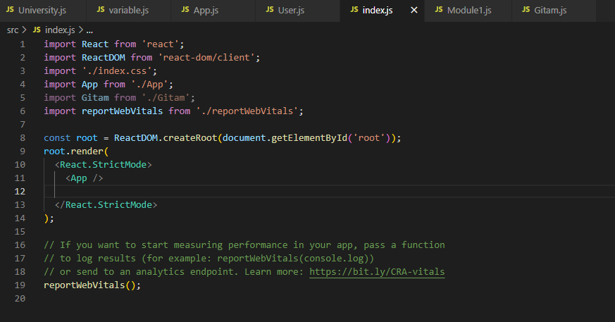

**5. Create a file called “Abc.js” in that file print “Virtusa,India,England”.**

**Take another file (“Xyz.js”), in Xyz.js print the University and school along with the content of Abc.js.**

**Take Another file(“Pqr.js”) , in Pqr.js print your name along with the content of Xyz.js.**

**In App.js print your roll number along with the content of Pqr.js**

**In Index.js import App.js and run the application.**

**Abc.js**

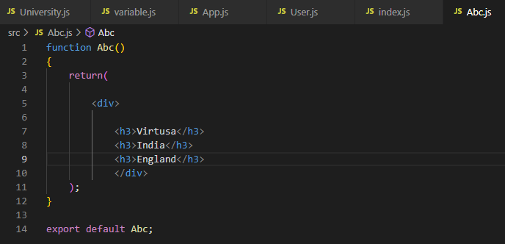

**Xyz.js**

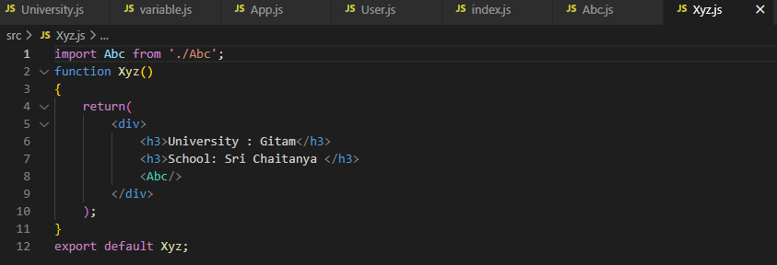

**Pqr.js**

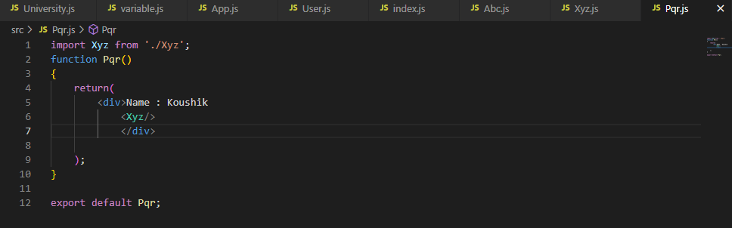

**App.js**

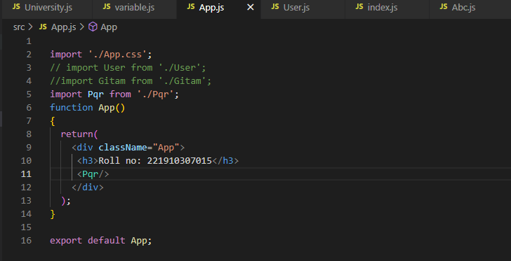

**Index.js**

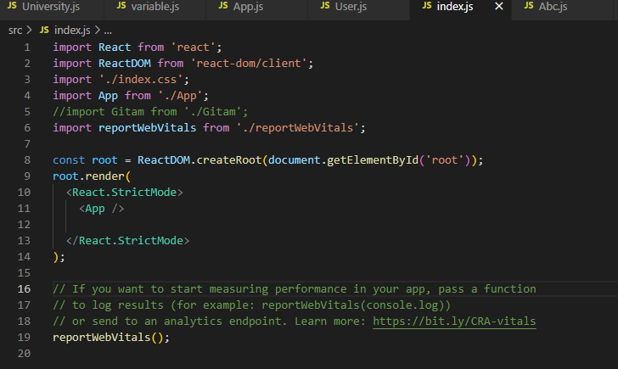

**Output :**

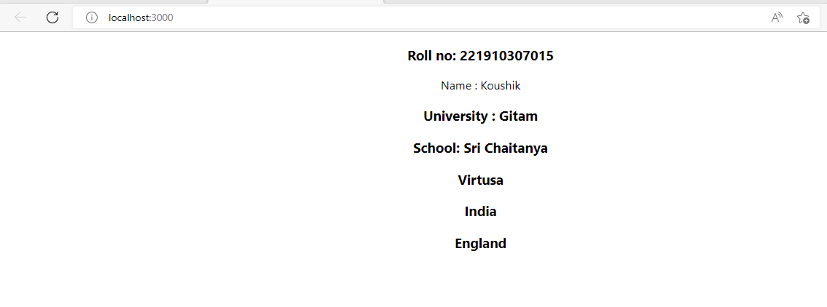

**6. Create a functional component (your name ) , in the functional component write about yourself and call this functional component in index.js file.**

**Koushik.js**

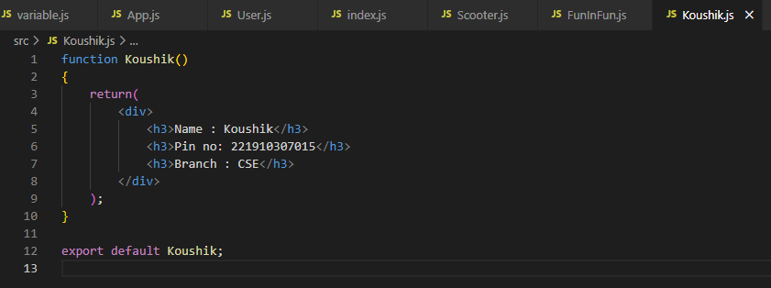

**Index.js**

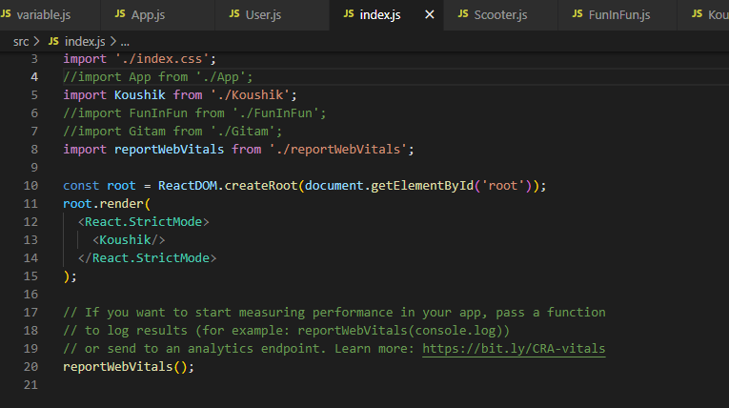

**Output :**

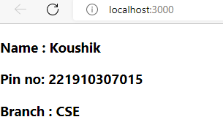

**7. Create a functional component inside a functional component.**

**FunInFun.js (Functional Component in Functional Component File)**

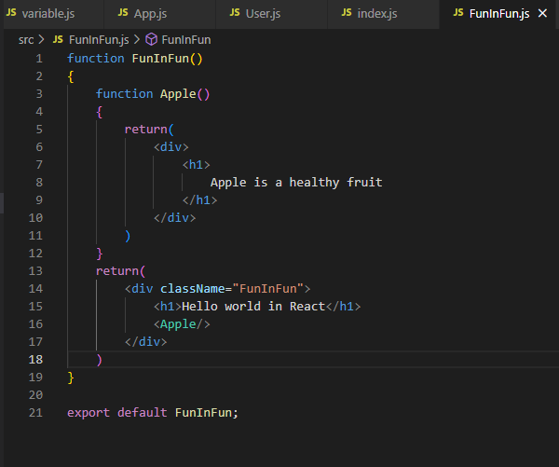

**Index.js**

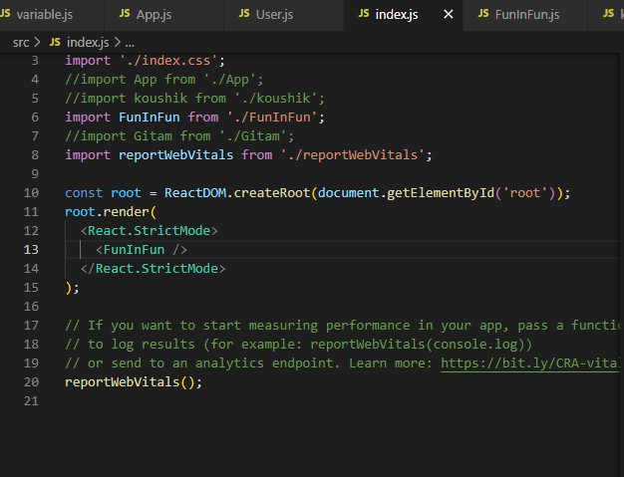

**Output:**

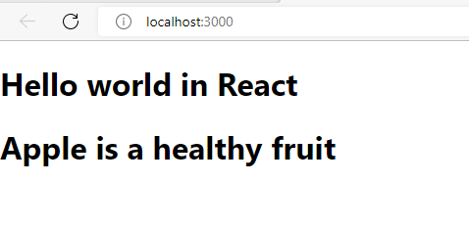

**8. Create a functional component “Car” inside a functional component in “App”, also call scooter in App.js ,then import App.js in index.js, then run the application.**

**Scooter.js**

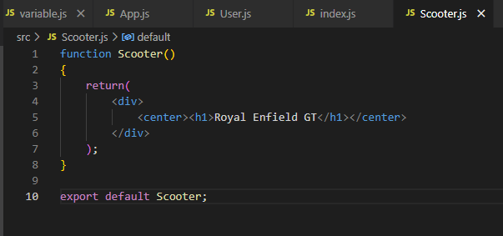

**App.js**

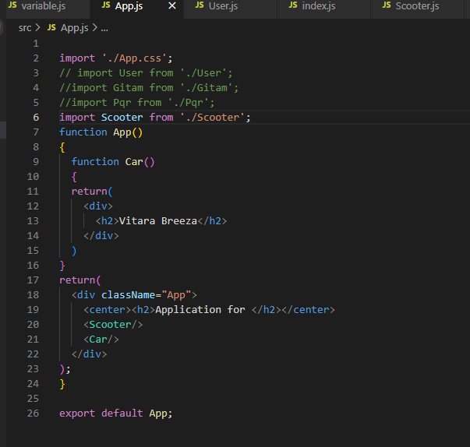

**Index.js**

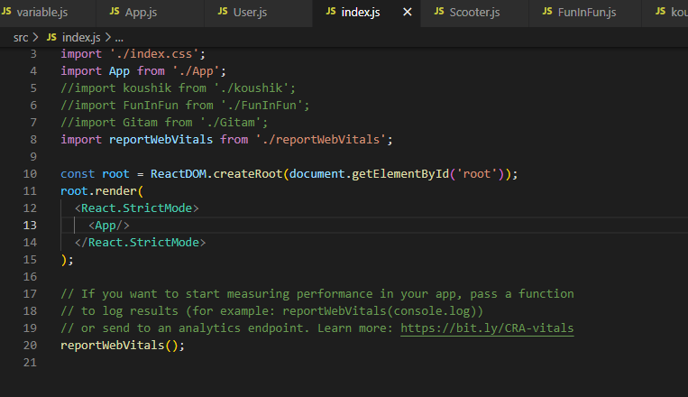

**Output:**

